1. Create Server and Max 3 Clients, 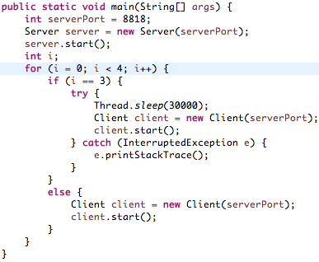

In the above code snippet, the server is created with port 8818. The server.start() function starts the server listening for new client connections. Subsequently, the main method creates 3 clients and starts them. The sleep clause is included so as to give the other clients enough time to disconnect so that a new client can be added if a previous one was disconnected.

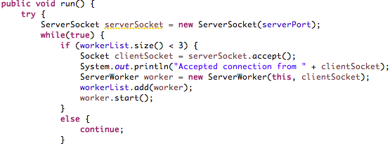

The above code shows that the server only listens for connections when there are fewer than 3 workers (corresponding number of clients) already connected to the server.

2. Access Codes and Client Names

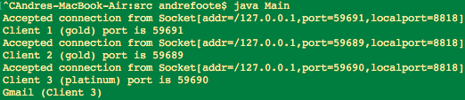

The above picture of the start of the program shows that 3 clients were created, given a name, and that their status (silver, gold, platinum) corresponds correctly with their port numbers.

3. Clients request dummy URL

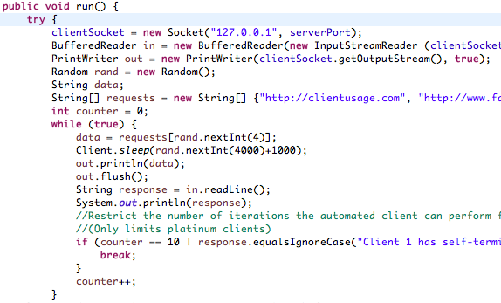

The above code snippet shows how a client object operates once it is connected to the server. It opens connections (input output streams) to the server. Every 1-4 seconds it chooses 1 of the 5 possible commands to the server. Server responses are displayed to the terminal.

|  |  |
| --- | --- |
| Dummy URL Request | Dummy Response |
| http://clientusage.com | Network Usage Details |
| http://www.facebook.com | "Facebook (" + clientName + ")" |
| http://www.gmail.com | "Gmail (" + clientName + ")" |
| http://www.reddit.com | "Reddit (" + clientName + ")" |
| quit | **this**.clientName + " has self-terminated its connection to the server" |

Please increase the counter limit to see platinum clients execute for more steps. Counter is initially set to 10.

4. Monitor/Enforce Access Categories, Disconnect on Quota, Read & Display Server Responses

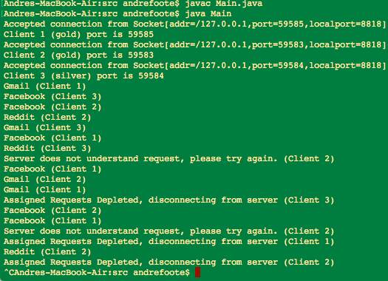

The above picture shows the execution and output of the code.

In the program execution shown above, it is observable that each client is disconnected from the server after it uses up its allotted URL request quota.

Ex. Gmail (Client 1): “Gmail” is the dummy response to client 1’s gmail.com request.

Client 1 and 2 makes 5 requests before being disconnected.

Client 3 makes 3 requests before being disconnected.

It is also observable that when a non-platinum client attempts to access clientusage.com, the “Server does not understand” the request. This is because that request is exclusive to platinum clients.

5. A client can be created as long as number of active users < 3

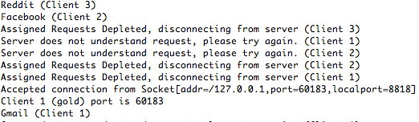

This image was taken from eclipse during testing requirement 7 of the project. As seen in the top of this picture, a previous “Client 1” was just disconnected from the server, but immediately afterwards a new “Client 1” was added.

6. Maintain clients’ usage details, Platinum client privileges

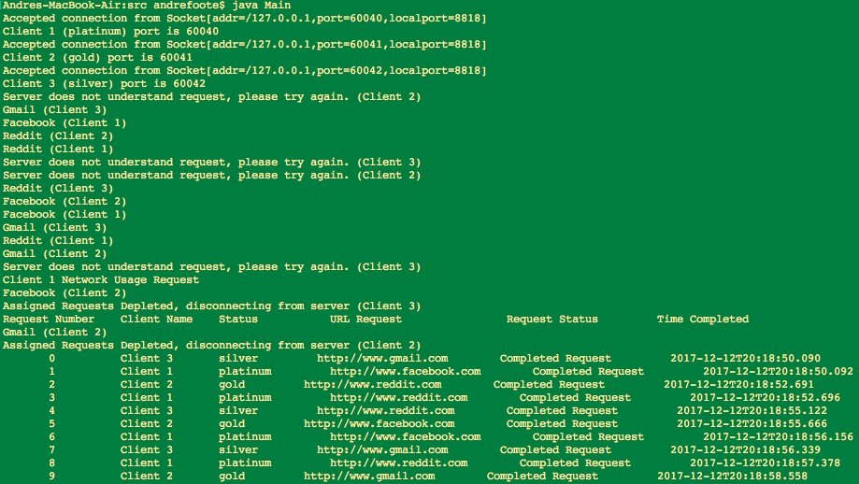

This image shows how the server is able to maintain a log of the requests it has received, and also that platinum clients can access this log to see its peers’ usage information. Without semaphore control the output is intermittent but the request information is in the correct order.